PRACTICAL SELF-IMPROVEMENT
Session 1: The benefits of happiness to build resilience in an uncertain world
Notes: “Wow” moments (make a note of the things which make you “click”…ie “wow moments” eg. key ideas, thoughts or statements – you can then refer to them in future)

EXERCISE 1: INSTRUCTIONS: Tick the behaviours that sound most like you (the please complete the rest in your own time)
- For all the ticks: In the next column outline what you believe about yourself to think that
- In the next column outline jot down any counter arguments for those beliefs
- In the last column write down an ATERNATIVE action next time you are in that situation
- If you do it, make a note on how it went!
EXAMPLE: I keep my thoughts to myself because I don’t think I have anything worth sharing | I believe others know more than me. I’m often in the wrong. I don’t have any ideas worth listening to. | My idea was used for the project that won an award. I was able to correct the mistake of a teammate before a report was handed in. | Next time I will make one suggestion to test the response of the group. (And I’ll also think about how THEY acknowledge my idea before I think it’s me at fault.)
Behaviours (habits) | What must I believe of myself to think that? | Examples the DISPROVE my thinking | What could I do instead (of column 1)
I keep my thoughts to myself because I don’t think I have anything worth sharing

If I’m not completely sure I can do something I think “Why bother trying”

I avoid talking to people because I’m worried about coming across poorly

I often second-guess myself

I often second-guess what others will do

I tend to apologise, even when I’m not in the wrong

I don’t tend to take risks because then I won’t fail

When I have failed I spend ages thinking about what went wrong

I give up easily

I often think “I’m not good enough”

I don’t ask questions because I believe others will laugh at me

I’ve missed out in the past because of fear or self-doubt

If you changed your response – reflect on how it might work and what your new thinking…and habits are.

Goal
To do list (segments)
Where are you (1-10)

What action will nudge the number upwards?
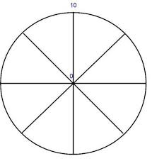
Of those actions, what ONE thing will you do today?

If you did it – how did it go

www.draudreyt.com
YouTube: Dr Audrey Tang https://www.youtube.com/channel/UCnn8-Waxrg6TmuNPHL1NQmg?view_as=subscriber
@draudreyt

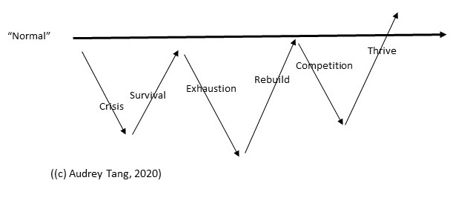
3 dip model of resilience (most models only see resilience as surviving crisis)

My Positivity Reservoir

My VALUES

3 GOOD THINGS/PEOPLE

