BUILDING RESILIENCE (emotional & mental strength)
Session 2: Anchor or weight?
Notes: “Wow” moments (make a note of the things which make you “click”…ie “wow moments” eg. key ideas, thoughts or statements – you can then refer to them in future)

ULTIMATELY: WHAT ARE YOU TRYING TO ACHIEVE eg Happiness? Success? (and be clear WHAT DOES IT LOOK LIKE TO YOU!?!

Unless related to wellbeing, these other goals may be bonuses!
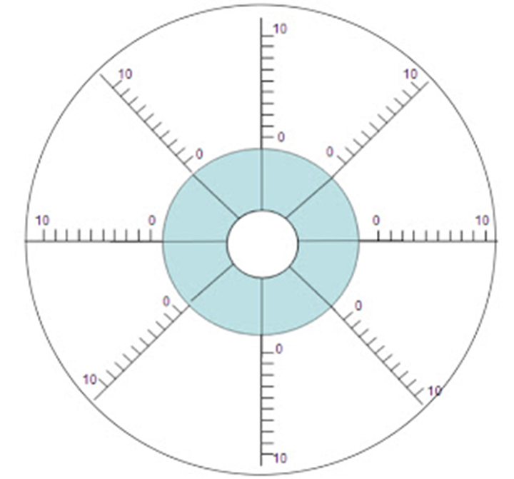

BARRIERS to GOAL

- Outline your barriers – BUT circle which are actually priorities eg: “LOCATION” but I DON’T want to move house because I love it, the kids love their school – then it’s a PRIORITY!!! You need to work AROUND it rather than overcome it!
Activating event (trigger) | Behaviour | Consequence | Dispute/Do | Energiser
EG: Friend hasn’t called | It must be MY fault | Feeling that everyone hates me/taking it personally  Shutting myself off from others OR in “survival mode” being a drain on others | I know we’re all busy, yesterday I had no time to call anyone if I wanted to. I’ll just call them! | THIS IS THE THING THAT MOVES YOU FROM “SHOULD” TO DO!!!  (e.g. feeling of empowerment)

10 quick energisers:
1. When in doubt, generate thoughts of gratitude (a person, a thing, an experience, a memory)
It is difficult to hold feelings of anger, fear or negativity as well as gratitude - at the same time. Therefore, while it is important to accept any negative feelings, and to address them, thinking about something in your life that you appreciate will help restore the emotional balance in order to address problems more effectively
2. Remember that you are awesome, and you’ve got this
If you’re reading this, maybe you just needed to be reminded, and here it is, you are enough. And to keep you in this upbeat frame of mind, here’s a question – what is a lovely thing someone has said about you? They didn’t need to say that you know – they did it because you’re great.
3. Say something kind to yourself about yourself
I’ve had a “love hate” relationship with my body, but even now I remember to thank it for allowing me to push it so hard!! And the more I respect it, the more I find we’re getting on! Maybe you’re going to praise your brain, your kindness, your ability to wake up at 5am – or maybe it’s that you’re having a good hair day – when you begin to recognise your worth, others will too.
4. Know that you can change your emotional state
Yes, sometimes we need a bit of help (such as upbeat music), but try the following questions and see how you go:
- How do I want to feel?
- What can I do that will make me feel that way now?
(then do it)…sometimes I just make myself smile…hold a (sanitised) pencil horizontally between your teeth if you need to…or think of me doing that!!
5. AFFIRMATION: Things will come in time
When you plant a seed, you don’t say things like “I’ll give you 10 minutes and you’d better grow”, so although you might want something, treat that desire like a seed – plant it, do all the things to nurture it, and be patient. (…and don’t forget, sometimes, you might grow more than you thought!!)
6. Recognise the value of what you have!!
When you start to see the value of things, you realise that you have more than you thought. I sometimes run from impulse purchase to impulse purchase – but now I take the time to really appreciate and make the most of what I have, and generally feel much richer than I ever have before!! (Try my 21 day #ilovemylife challenge!! Despite longing for things (people, possessions, pets, job, house...) once we have them, unless we work to appreciate them, they can lose value for us. This challenge is about getting you to recognise the abundance you already have, even while you're on your route for more. Every day take 1 photo of something or someone in your life right now that you love, and you will realise you are rich indeed.)
8. Set a positive intent for today such as: Today will be a great day!
This immediately makes you feel energised, and if you need a little help knowing you’ll be ok – think of 3 good/nice things that happened yesterday!
9. If you catch yourself enjoying a moment – take another one to savour it
We so often rush through our day, yet - how much will that extra moment take, compared with how much it will give? Stop, breathe, and if you need to remind yourself – even if I can’t control anything else right now, I can control my breathing in this moment!! Stay strong!
10. Do something you love – for it’s own sake – not to show off

MISSING LINK REFLECTION:
INSTEAD OF LOOKING AT WHAT HAPPENED, REFLECT TO FIND OUT WHAT WAS “MISSING”
- Are there any behaviours you know are effective which you do not always engage in?
- Why not?
- How can you encourage yourself to “try” it?

ADOPT METHOD
- Act (Respond not react – but you must respond!...and then work to be pro-active)
- Deal (Before it gets bigger)
- Optimise (Even negative experience can be learned from)
- Prepare (Plan ahead)
- Thrive (energiser)

PERMA – are you balanced?
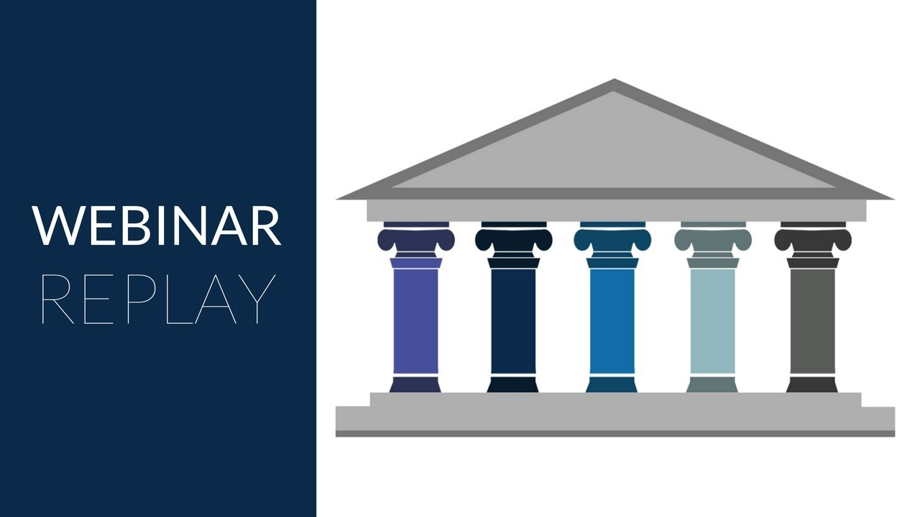
ACCUMULATE POSITIVE EXPERIENCES by trying some of the following
1. Appreciation of Beauty & Excellence: Reflect for a moment on the beauty that others may miss - the chrysalis protecting the butterfly; a cool breeze on a warm day; a warm drink on a cold one.
2. Bravery: Voice that thing you've held back on. You can do it kindly...and if you find you cannot speak authentically with some, recognise the people with whom it is possible and try to spend more time in their company or the company of people like them.
3. Creativity: Think of two different ways of approaching a problem that you have not used before.
4. Curiosity: "I'm just trying something" is one of my favourite phrases. Do something new today, whether it's trying a new food, or style, or learning something you didn't know. It doesn't have to cost money nor take long to give it a go (and you don't need to stick with it if it doesn't work!)
5. Fairness: Can you offer your voice to someone or something that has been previously overlooked?
6. Forgiveness: When we forgive we do it to release the negative control others have over us - we do not do it to condone, nor forget. Try this lovely Hawaiian prayer "Ho'oponopono": Think of the thing/person you wish to move on from and say "I'm sorry, please forgive me, Thank you, I love you." (You may even find you are saying it to yourself for any part in allowing the situation to happen).
7. Gratitude: Tell someone you love how grateful you are to have them in your life - and tell them why too!
8. Honesty: Find a way of expressing an inner truth - perhaps a drawing, or journaling. You don't need to tell others, just be honest with yourself.
9. Hope & optimism: Reflect on a situation with optimism whether it's over what you are learning, or your knowledge that you are strong enough to get through. Write down any realistic thoughts that make you feel better about it or you.
10. Humility: Seek feedback from someone you trust on an area that you may want to develop.
11. Humour: Instead of instinctively choosing defensiveness, consider whether humour would help to call something out in a situation where you might feel you are slighted (it may at least open good natured dialogue).
12. Judgment (critical thinking): Double check something for its validity or reliability before you share it on social media.
13: Kindness: Check in on someone today.
14.Leadership: Support someone else in developing their strengths by asking them if they have any traits they wish to develop.
15.Love: Surprise someone who cares for you with a funny message, or maybe a hot drink or little treat.
16. Love of learning: Read something that inspires you and reflect on its meaning.
17. Perseverance: Praise yourself for the number of times you have been able to keep going - even when it was tough.
18. Perspective: For something you may be struggling with - see if you can seek two different perspectives on it.
19. Prudence: Even for an easy decision, take a moment to ask yourself - what do I want to achieve - before you choose.
20. Self regulation: Remind yourself that even in a difficult moment where you feel like you cannot control anything - you can at least control your breathing...and take a deep breath in for 4, hold for 2, and out for 6 - then proceed.
21. Social Intelligence: Listen to the point of view of someone outside your "echo chamber". You do not have to agree, but it can be helpful to be aware that there are many complexities to opinions...it reminds us too that when we are disagreed with, it doesn't necessarily mean anyone is "wrong" or needs to feel threatened.
22.Spirituality: Find a podcast or affirmation video that you enjoy and give yourself 10 minutes to focus on it.
23.Teamwork: Find one thing to praise about your team (this can be your work or sports teams, or your team of family and/or friends too!!)
24. Zest & enthusiasm: Do something that raises your vibe for YOU eg. playing music, eating a food you like, looking at something you love. We can be brought down by surrounding negativity (so also unfollow any social media accounts that don't make you feel great) - therefore we need to always top up our personal supply.

SAMPLE “COPE AHEAD” personnel chart (some may be friends, others professionals – choose the right person for the role!!):
You share a sense of humour with | Can help signpost/advise you as needed | Lives near you to call on in an emergency
Knows how to look after your pet – and would be willing to | Has skills in  __________  (enter YOUR desire to learn) | Has travelled to __________(enter YOUR desired destination)
Is on your wavelength | Offers you support | You feel energized after seeing
FIND SOMEONE (OR MANY PEOPLE) WHO…

WHAT’s YOURS and who features?

www.draudreyt.com
YouTube: Dr Audrey Tang https://www.youtube.com/channel/UCnn8-Waxrg6TmuNPHL1NQmg?view_as=subscriber
@draudreyt

