PRACTICAL SELF-IMPROVEMENT
Session 2: Managing stress and anxiety
Notes: “Wow” moments (make a note of the things which make you “click”…ie “wow moments” eg. key ideas, thoughts or statements – you can then refer to them in future)

Note that anxiety is one of the ways we may name our physiological response to stress!
The Diary Card is used within DBT. It asks you to track your emotions through the week, looking also at how you deal with them. This is a very basic version
Trigger What I did Rate success
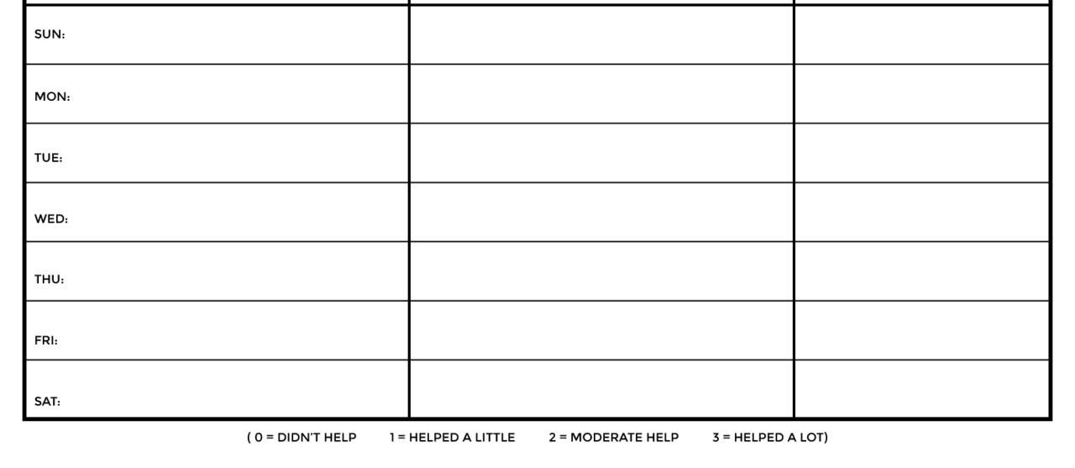

Create a “Calm kit”
- Useful numbers
- A fan
- Food
- A stress ball
- Reminders of how to respond!!
- …whatever you need to feel better (some people include tea!)

STOP
Stop
Take a Step Back
Observe
Proceed

TIPP
Temperature
Intensity
Pace Breathing
Paired Muscle Relaxation

Wellbeing wheel and self compassion
Note what works best for you – some will fall into the “yin” (soothing) category, others into the “yang” (energising) one.

Change is most effective when it starts at the TOP, but the practical tools can help you get there… It’s why we use a mix of mental and practical strategies.
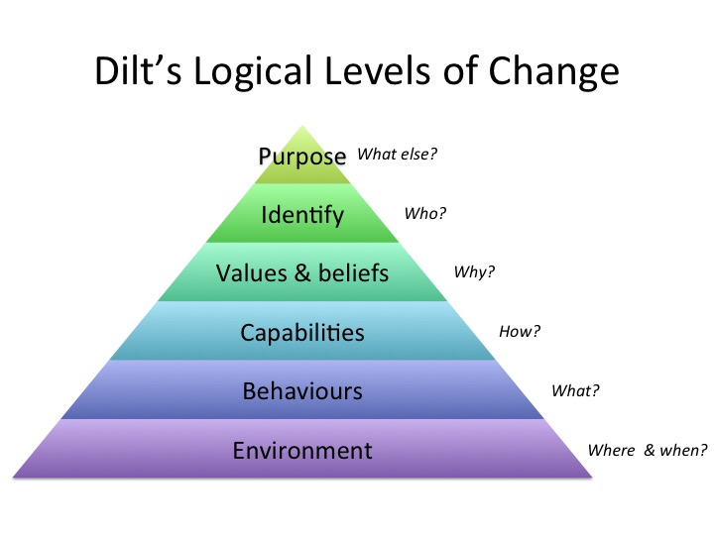

Dealing with the root
- 1. Have the discussion when you are NOT hugely emotional (otherwise it is likely to turn into an argument where “winning” becomes the goal, not solving the problem) – sometimes you need to walk away, then return to the discussion…but if you are going to walk away – tell the other person/people you need a moment and you will be back. (Then come back!)
- 2. Have your agenda written out if you can – it is easy to be pulled off track and again it is important to keep focus on resolution
- 3. Hold the discussion somewhere neutral if you can
- 4. Have an idea of what you want as a solution but be flexible – and then listen.
- 5. If you can, try to avoid “blame” language eg. “You were mean…” it is healthier to focus on what is under your control eg. “When you said X, I felt…” – it may even be that the issue lies in communication rather than in the actual event that occurred.

