BUILDING RESILIENCE (emotional & mental strenghth)
Session 1: The art of BEING well!
Notes: “Wow” moments (make a note of the things which make you “click”…ie “wow moments” eg. key ideas, thoughts or statements – you can then refer to them in future)

IDEAL ME exercise
- What 3 behaviours does the ideal me do?

- Who does the ideal me “hang out” with? (e.g. the values of those people)

- How does the ideal me talk to myself/others?

- How does the ideal me think?

- How does the ideal me behave?

www.draudreyt.com
YouTube: Dr Audrey Tang https://www.youtube.com/channel/UCnn8-Waxrg6TmuNPHL1NQmg?view_as=subscriber
@draudreyt

Then reflect each day:
- How did I do?

- Where did I stumble and why?

- WHO did I react to and where was it?

- What could I do next time?

REMEMBER – what you practice becomes habit

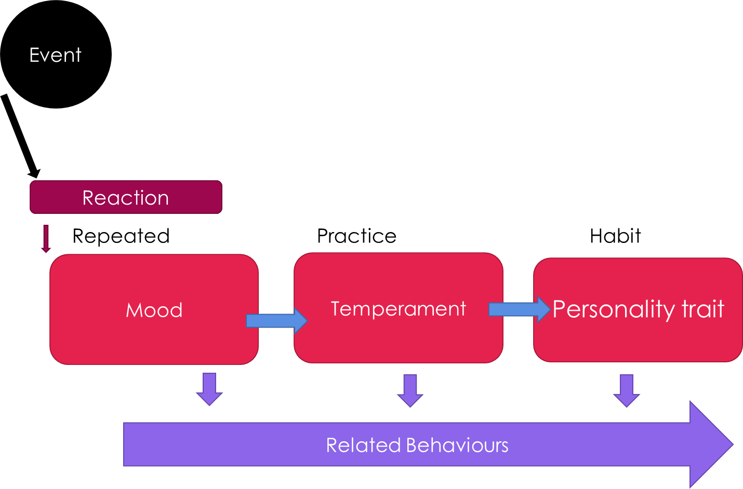

What works for me (PERMA):
(YOU MAY WISH TO UPDATE THIS EACH WEEK AS WE COVER MORE EXERCISES)
What I tried | POSITIVE EMOTION | ENGAGEMENT | RELATIONSHIPS | MEANING | ACHIEVEMENT
Week 1

Week 2

Week 3

Week 4

Week 5

Week 6

Week 7

Week 8

And also remember the PRACTICAL TOOLS available to you.

