PRACTICAL SELF-IMPROVEMENT
Session 5: Navigating change successfully
Notes: “Wow” moments (make a note of the things which make you “click”…ie “wow moments” eg. key ideas, thoughts or statements – you can then refer to them in future)

Imagine you have the ability to time travel. Go forward to a time where you ARE living your best life – you are doing everything you want to do, you are with the people you want to be with – remember last week’s workbook:
- What does it look like?
- What’s your house like?
- Who are you with?
- What are your doing? (What’s your morning routine?)
- If you are CLEAR on that (which if you did last week’s session, then you will be – and if you didn’t you can download the workbook from www.draudreyt.com (workbooks) – sub heading under consultancy. REMEMBER we need to be clear and focused on our goals – otherwise how will we know we’ve achieved? Yes, those goals can change, but always have a clear idea to focus on.
- NOW speak to your ideal self living your best life and ask them – what things did you do to get there?
Write down some of those things – because THAT is where to start.

The DILTS model of change
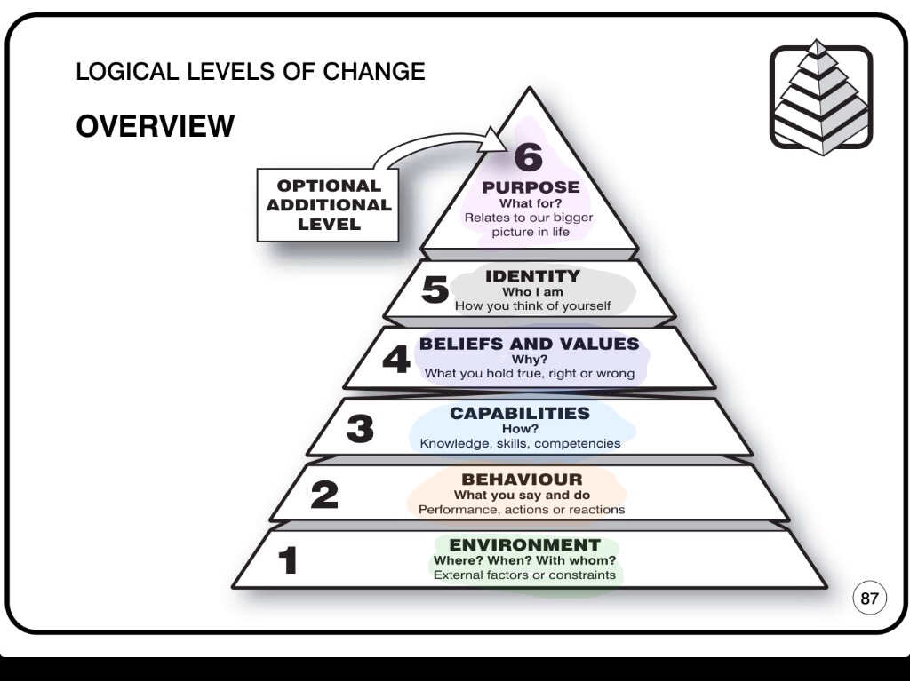

Reflect on whether your coaching wheel tool worked for you

What tweaks will you make?

Change models:
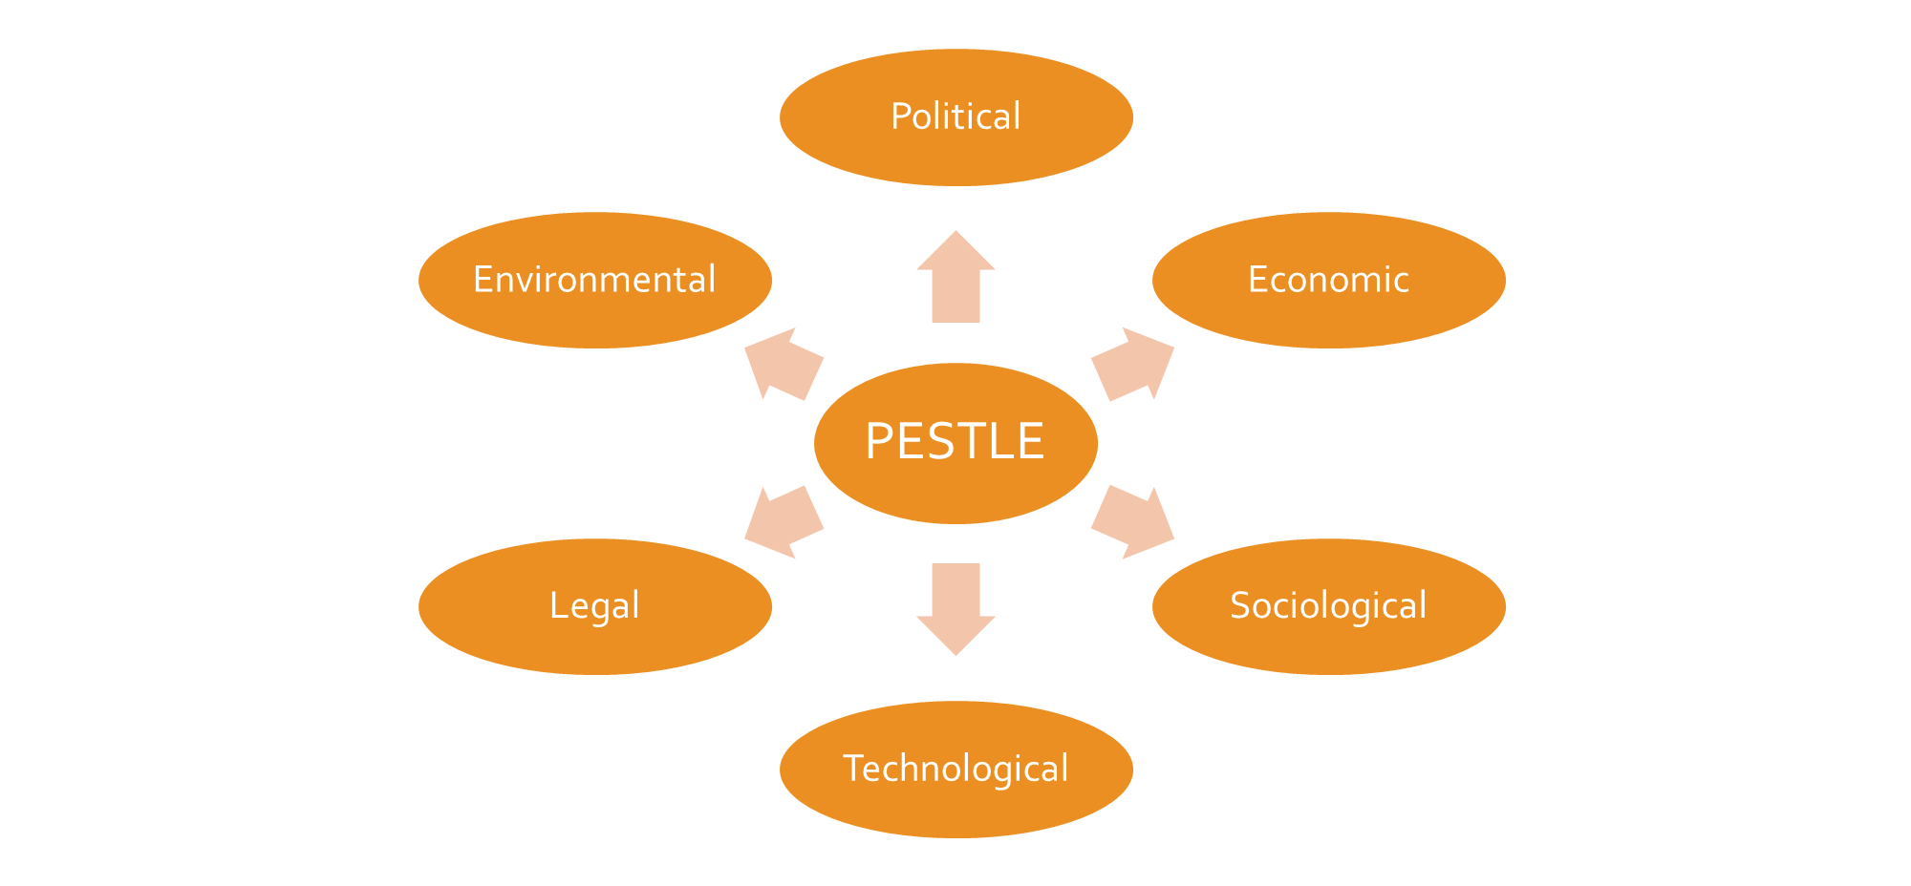

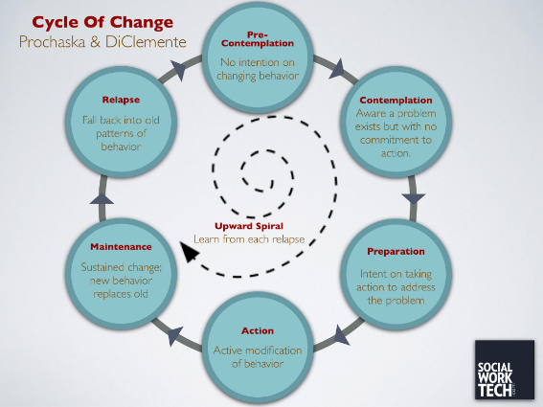

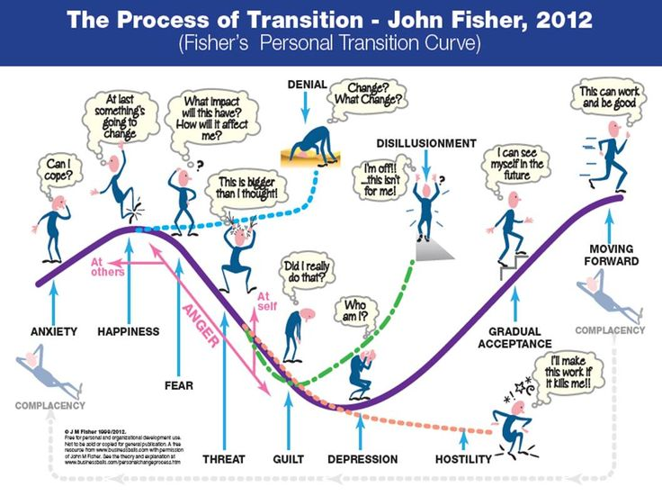

Note down the “excuses” you use – if you recognise them, it means you can do something about it

For ANY goal - What is your WHY:

SMART targets:
Specific
Measurable
Achievable
Realistic
Time-dependant

What am I enjoying doing (without my friends)?

Quick self-help reminder:
WHO I can call on for help
WHAT actions I CAN take which help you reach your goal
My WHY!

