BUILDING RESILIENCE (emotional & mental strength)
Session 9. Find authentic joy
Notes: “Wow” moments (make a note of the things which make you “click”…ie “wow moments” eg. key ideas, thoughts or statements – you can then refer to them in future)

FULL LIFE AUDIT (www.inc.com):
- What are my assets and liabilities (not just things but also personality traits, skills, habits, etc.)?

- How could I be kinder to or support myself?

- How could I be kinder to or support others?

- What would I still like to learn and how could I do so?

- Do I have one to five good friends I can trust and count on?

- Do I feel energized, neutral, or let down about my work?

- Am I in good health or pursuing it to the best of my ability?

- Do I spend my free time doing a variety of enjoyable activities?

- What emotion is dominant for me?

- What do I get excited about consistently?

- What core principles (e.g., honesty) do I have, and how does my way of living reflect them?

- What would I do with more or less money?

- What am I grateful for and why?

- What do I regret and why?

- How close is what I'm doing professionally to what I dreamed of doing?

- Am I consistently challenging myself?

- What fears do I have?

- What are the top five words I think others would use to describe me?

- What are the top five words I would use to describe myself?

- Are the motivations behind my original goals still present?

- What do I find myself daydreaming about when I'm supposed to be doing other things?

- What is my financial or material standard of living, and have I achieved it?

- What in my current environment do I like or dislike?

- How am I influencing others for better or worse?

- Is my income stable?

- How is my weight?

- Do I feel confident in my appearance?

- Do I feel like I have worth?

- Can I do most things with independence and confidence?

- Am I able to make decisions easily?

- Am I able to lead myself and others spiritually?

- What goals do I have?

- Why didn't I meet goals I've previously had?

- Am I engaged in personal development?

How can I reframe my past?

Envisioning my ideal future

- What do I love about my life right now (ie. Things I want to “take” with me)
- What do I feel is “Missing” – and how do I find it?
- What do I want people to say of me when I’m gone/What impact do I want to make on the world?
- Do I have a daily routine, and how can I be more intentional?
- What ONE thing could I do now that would bring me closer to my ideal?
- What is one negative view I need to remove?
- How can I do more of what I love daily?
- What can I do to incorporate more self love/care into my day?

My best plotlines

- What are your biggest accomplishments last year?

- Identify 3 of your most joyful moments

- Identify 3 things you did well/are proud of

- When things go wrong – focus on your positive intentions, and learn from the mistakes

- Identify 3 times you showed courage

- Identify 5 people you have helped in your life

- Go and express gratitude (right now) to the people who love and support you.

End of day reflection

- What did I do well?
- What could I have done better?
- What can I learn from today?
- What will I do differently tomorrow/in the future?

Managing emotional tilt
Trigger | Consequence | Alternative

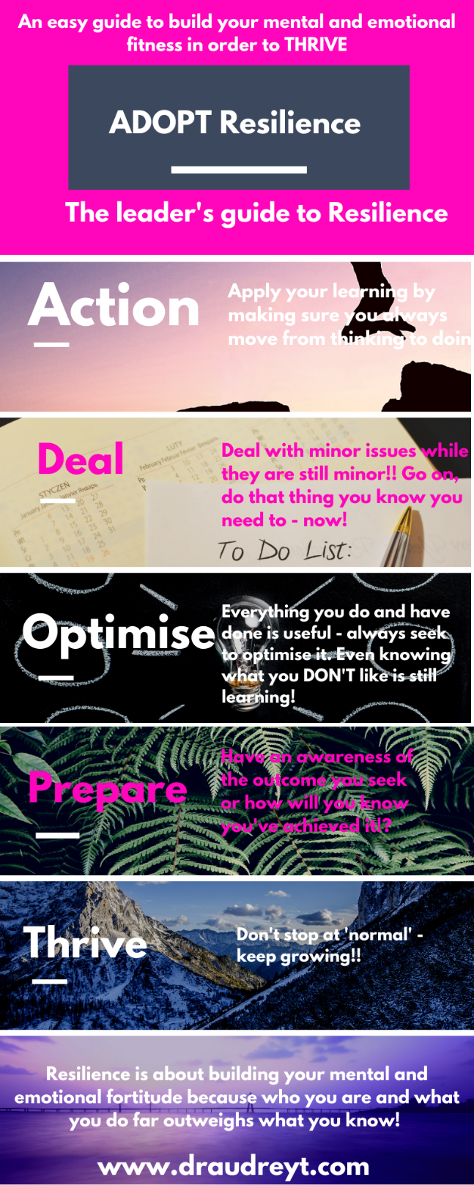

Find Joy in yourself:
- PLAY/LAUGH like a kid
- Get out in nature
- Learn something new (achievement makes us feel great)
- Stroke a pet (oxytocin)
- Practice gratitude
- Listen to music/dance/jump around
- Meditate – ACTIVE OR CALMING

www.draudreyt.com
YouTube: Dr Audrey Tang https://www.youtube.com/channel/UCnn8-Waxrg6TmuNPHL1NQmg?view_as=subscriber
@draudreyt

