PRACTICAL SELF-IMPROVEMENT
Session 3: Decision Making
Notes: “Wow” moments (make a note of the things which make you “click”…ie “wow moments” eg. key ideas, thoughts or statements – you can then refer to them in future)

- Think of a “good” decision you made

- Now think of a bad one

- Improve your decision making by focusing on the PROCESS of how you make choices not just on the outcome.
1. Frame the decision
2. Gather information
3. Come to a conclusion
4. Make the decision
5. Learn from feedback

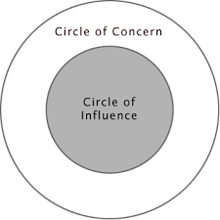

1

10

20

30

40

50

60

70

80

90

100

